Luxury Housing Sales Analysis – Bengaluru

- Overview :
The project aims to analyze market trends, correlation between the features, create new features from existing data and handle the null values . The goal is to create refined data from raw data and load the data from sql into Power BI designation. Finally create an interactive dashboard using Power BI DAX measures.
Project Deliverables:
- Read the data from csv format and convert it to the data frame using pandas
- Understanding the data , like how many columns ,rows, datatypes, then identifying the required target column and all of that.
- Some columns are incorrect format, after that I corrected the data type for those columns.
- Removing the unwanted symbols from the target column.
- Getting the idea about null values and imputing median values in those columns.
- The target column also has null values. We cannot impute so that drop the rows
- Also done for Feature Engineering from the existing data.
- Finally got refined data. Made the connection between the python and SQL store all the data into database
- Made a live connection between SQL and power BI using DAX measure created interactive Dashboard.

- Objective:
An analysis environment using a complex housing dataset with 1,00,000+ records create refined data. Finally created meaningful Dashboard insights, like builder performance, market trends, correlation between Amenity score and booking conversion rate. Track real estate patterns across fiscal quarters to aid investment decisions.
Pipeline steps:
- Loading the data
- Understanding the data
- Corrected column data types
- Handling null values
- Removing null values target column
- Stored data SQL database
- Make a live connection between power BI and SQL
- Performing ETL (Extract Transform Load)
- Dax calculations
- KPI visuals and filters
- Identifying business insights
- Finally created meaningful Dashboard

- SQL schema:
Connection:
import mysql.connector
from mysql.connector import Error
try:
connection = mysql.connector.connect(
host = 'localhost',
user = 'root',
password = '123456789',
autocommit=True )
if connection.is_connected():
print("Connection to mysql is successful")

except Error as e:
print('Error while connecting to MySQL.', e)

Stored Data To SQL Database:
Create Table
query = """CREATE TABLE IF NOT EXISTS Luxury_house_sales (Property_ID VARCHAR(255), Micro_Market VARCHAR(255), Project_Name VARCHAR(255), Builder VARCHAR(255),Unit_Size_Sqft FLOAT , Configuration VARCHAR(255), Ticket_Price_Cr FLOAT ,Transaction_Type VARCHAR(255), Booking_Status VARCHAR(255), Purchase_Quarter DATE,Connectivity_Score FLOAT , Amenity_Score FLOAT , Possession_Status VARCHAR(255),Sales_Channel VARCHAR(255), NRI_Buyer VARCHAR(255), Locality_Infra_Score FLOAT,Avg_Traffic_Time_Min INT, Buyer_Comments VARCHAR(255), Price_per_Sqft FLOAT ,Quarter_Number INT, Booking_Flag INT)"""
cursor.execute(query)

Inserted data to table:
data = df.values.tolist()
query = "INSERT INTO Luxury_house_sales values (%s, %s, %s, %s, %s, %s, %s, %s, %s, %s, %s, %s, %s, %s, %s, %s, %s, %s, %s, %s, %s)"
cursor.executemany(query, data)
connection.commit()
- Dax calculations :
Created columns:
Date = FORMAT('house_sales luxury_house_sales'[Purchase_Quarter], "DD-MM-YYYY")
Year = YEAR([Purchase_Quarter])
Created new measure:
booking = CALCULATE([Total_visit], 'house_sales luxury_house_sales'[Booking_Flag] = 1)
Total_visit = COUNTROWS('house_sales luxury_house_sales')
Total_Ticket_price = SUM('house_sales luxury_house_sales'[Ticket_Price_Cr])

- Business insights:
We can find below insights for house sales project.
Business case:
- Market Trends:
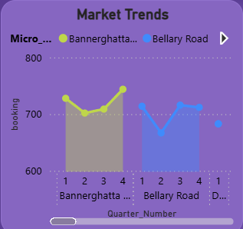
We can see over here how booking rates changed over the quarters across micro markets. For example, Bannerghatta has 1st and 4th quarters having highest booking compared to 2, 3 quarters.

2. Builder Performance :
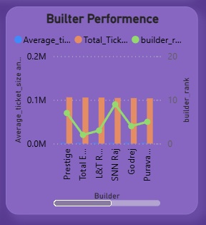
Builder Performance, which means, in this scenario, i have calculated total ticket sales for each builder and i have given rank for those builders based on average ticket sales.
Example:
Prestige is the highest ticket sales but on average they ranked 7th place.
3.Amenity Impact:
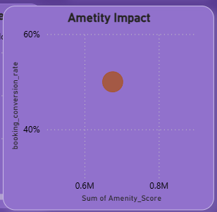
In this case we must find correlation between the amenity score and booking conversion rate. First, I must calculate the booking conversion rate using the Dax formula and plotting the scatter plot. Here amenity score and booking conversion rate have positive correlation.
4. Booking Conversion:
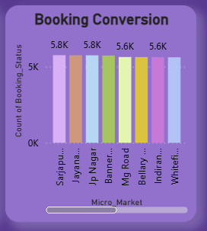
Booking conversion, which means here we must find out which micro market has the highest and lowest booking conversion rate. Here Sarjapur has the highest conversion rate and Hennur has the lowest booking conversion rate
5.Configuration Demand:
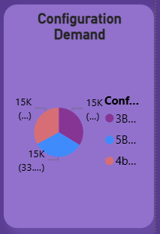
Here is a pie chart showing proportional distribution of configuration demand data. Here we must find which configuration has highest demand in Bangalore city. The above picture shows the configuration having equal demand.
6. Sales Channel Efficiency:
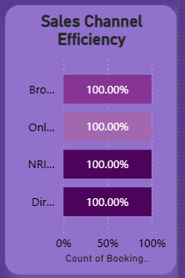
we must decide which channel has the highest successful booking rate, here the above plot shows every channel has an equal successful rate.
7. Quarterly Builder Contribution:
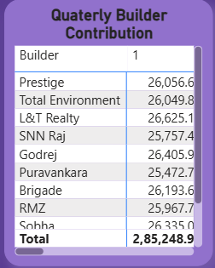
We must find which builder is most dominant for each quarter .The above plot shows prestige is the highest one for all the quarters to compare others.
8. Possession Status Analysis:
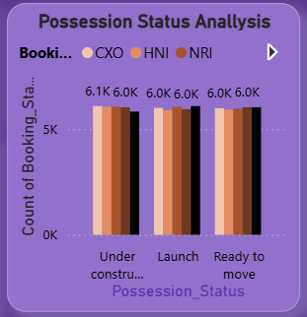
Here possession status analysis whether a property is "Ready-to-Move-In" (RTM) or "Under-Construction" (UC)significantly impacts buyer type. The above plot shows slightly decreased booking count in under construction.

9. Geographical Insights:
Where are most luxury housing projects concentrated within Bangalore?
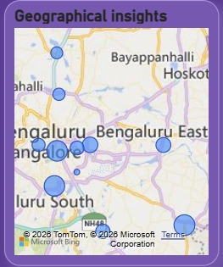
The plot above shows that based on bubble size we can easily identify Sarjapur road, followed by Jaya Nagar, Jp Nagar has highest housing project Concentrated in Bangalore.
10. Top Performers:

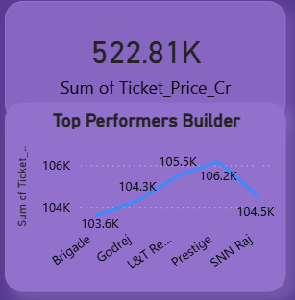
In Bangalore, prestige, SNN Raj, Godrej and Brigade builders are the highest performers. Total ticket price is 5228.1 cr
Complete Insights visual.
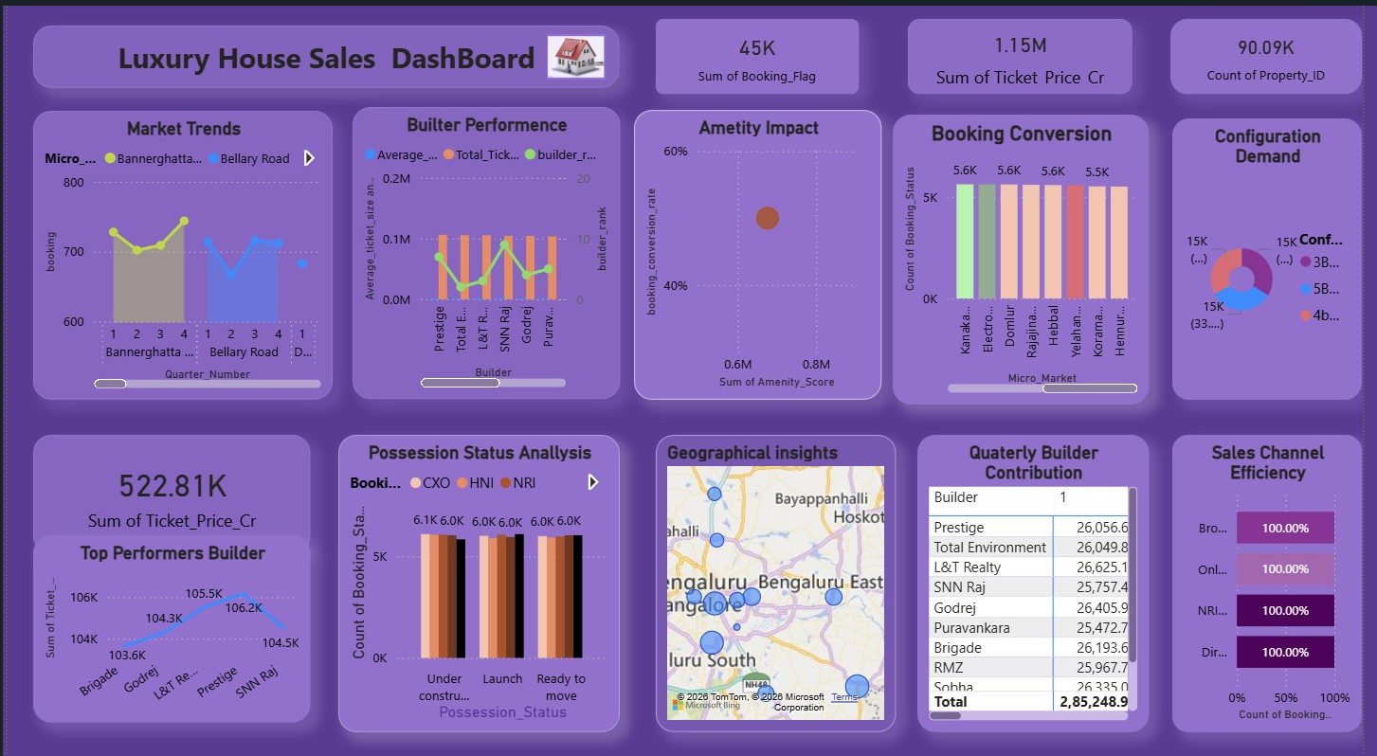

Conclusión:
The implementation of the data pipeline and analysis are done with large housing dataset (1,00,000+ records), and providing valuable insights into the market trends, pricing, and customer preferences and also found average ticket sales price are examined with data.

